

Labyrinth

Prepared for:

**#Developer Team#**

Document date: **20.10.2014**

Software Design Document

*© Global Software Foundation 2014. All rights reserved. No part of this document may be reproduced in any form without the prior written permission of Global Software Foundation. Warning: The doing of an unauthorised act in relation to any copyright work may result in both a civil claim for damages and criminal prosecution.*

Contents

1 Introduction 2

1.1 Document Information 2

1.2 Purpose 2

1.3 Scope 2

1.4 Application Benefits 2

1.5 References 2

2 Requirement Summary 3

3 System Overview 4

4 System Architecture 5

4.1 Architectural Design 5

4.2 Decomposition Description 5

4.3 Design Rationale 5

5 Data Design 6

5.1 Data Description 6

5.2 Data Dictionary 6

6 Component Design 7

7 Human Interface Design 8

7.1 Overview of User Interface 8

7.2 Screen Images 8

7.3 Screen Objects and Actions 8

8 Appendix 9

Appendix 12

List of Changes

author(s) : Sussi Lagerström & Jens Brännback

version : 1a Template

status : Draft

source : Global Software Foundation

document date : 20 October 2014

number of pages : 10

owner : Global Software Foundation

| Version | Date | Description | Author(S) |
| --- | --- | --- | --- |
| 1.a | 20/10/2014 | Software Design Document Template | Sussi Lagerström |
|  |  |  |  |
|  |  |  |  |

Glossary

|  |  |
| --- | --- |
| Term | Description |
|  |  |
|  |  |
|  |  |
|  |  |
|  |  |
|  |  |
|  |  |
|  |  |
|  |  |
|  |  |

# Introduction

## Document Information

| Proposal Name |  | | |
| --- | --- | --- | --- |
| Document Reference Number: |  | Document Version No: | 1.a |
|  |  | Document Version Date: | 20/10/2014 |
| Author | Sussi Lagerström | | |

## Purpose

This software document describes the architecture and system design of Blind Labyrinth. The intended audience of the document are all the people involved in the design process of the application. The purpose of the document is to keep everyone informed of the status of the project.

## Scope

The software is a labyrinth application in which the player has varying amount of visibility of the labyrinth. The goal is for the player to find a way from the beginning of the labyrinth to the end. This is done by memorizing the route, tilting the tablet and listening to the audio feedback from the moving ball. The game challenges the player’s visual spatial memory and motoric skills.

## Application Benefits

Development of the player’s non-verbal intelligence, problem solving skills and visual spatial memory.

## References

# Requirement Summary

**Technology:**

The system should be android 4.0 compatible. Resolution is compatible with different devices (800x480px (?) and up). Functional with single core processor.

**Feedback:**

The feedback of the system are based on audio queues. The system reacts to speed of the ball (dependent on the angle of the device), collision with walls and the ball reaching the goal.

**Rewards:**

The reward system is based on the player collecting tokens. The player gets different amount of tokens depending on the difficulty of the chosen level: fully visible, ball leaving trace, glowing ball and a totally dark labyrinth (see Figure 1-3).

**Continuity:**

Collecting tokens and increasing the difficulty of the tokens keep the player interested in playing the game.

# System Overview

#Give a general description of the functionality, context and design of your project. Provide any background information if necessary#

# System Architecture

Arcada studeranden fyller i.

## Architectural Design

#Develop a modular program structure and explain the relationships between the modules to achieve the complete functionality of the system. This is a high level overview of how Software Design Document & responsibilities of the system were partitioned and then assigned to subsystems. Identify each high level subsystem and the roles or responsibilities assigned to it. Describe how these subsystems collaborate with each other in order to achieve the desired functionality. Don’t go into too much detail about the individual subsystems. The main purpose is to gain a general understanding of how and why the system was decomposed, and how the individual parts work together. Provide a diagram showing the major subsystems.#

## Decomposition Description

#Provide a decomposition of the subsystems in the architectural design. Supplement with text as needed. You may choose to give a functional description or an object oriented description. For a functional description, put top level data flow diagram (DFD) and structural decomposition diagrams. For an OO description, put subsystem model, object diagrams, generalisation hierarchy diagram(s) (if any), aggregation hierarchy diagram(s) (if any),interface specifications, and sequence diagrams here.#

## Design Rationale

# Discuss the rationale for selecting the architecture described in 3.1 including critical issues and trade/offs that were considered. You may discuss other architectures that were considered, provided that you explain why you didn’t choose them#

# Data Design

Arcada studeranden fyller i.

## Data Description

# Explain how the information domain of your system is transformed into data structures. Describe how the major data or system entities are stored, processed and organized. List any databases or data storage items#

## Data Dictionary

#Alphabetically list the system entities or major data along with their types and descriptions. If you provided a functional description in Section 3.2, list all the functions and function parameters. If you provided#

# Component Design

Arcada studeranden fyller i.

#If you gave a functional description in section 3.2, provide a summary of your algorithm for each function listed in 3.2 in procedural description language (PDL) or pseudocode. If you gave an OO description, summarize each object member function for all the objects listed in 3.2 in PDLor pseudocode. Describe any local data when necessary#

# Human Interface Design

## Overview of User Interface

The application is a blind labyrinth used on tablets. The aim of the game is for the player to navigate a ball through the labyrinth without/only partly (see Figure 1-3) fseeing the labyrinth. In the game the user first sees the labyrinth for a few seconds. The picture is then covered and the user has to navigate through it only based on his/her memory of the labyrinth and on the sound from the ball touching the walls. Once the player reaches the goal the device will give an audio feedback.

To think about:

* Being able to choose labyrinth vs. the game choosing it for the player once a labyrinth has successfully been accomplished
* Time that the labyrinth is visible
* Being able to take a look at the labyrinth while playing (if player has forgotten the route)

## Screen Images

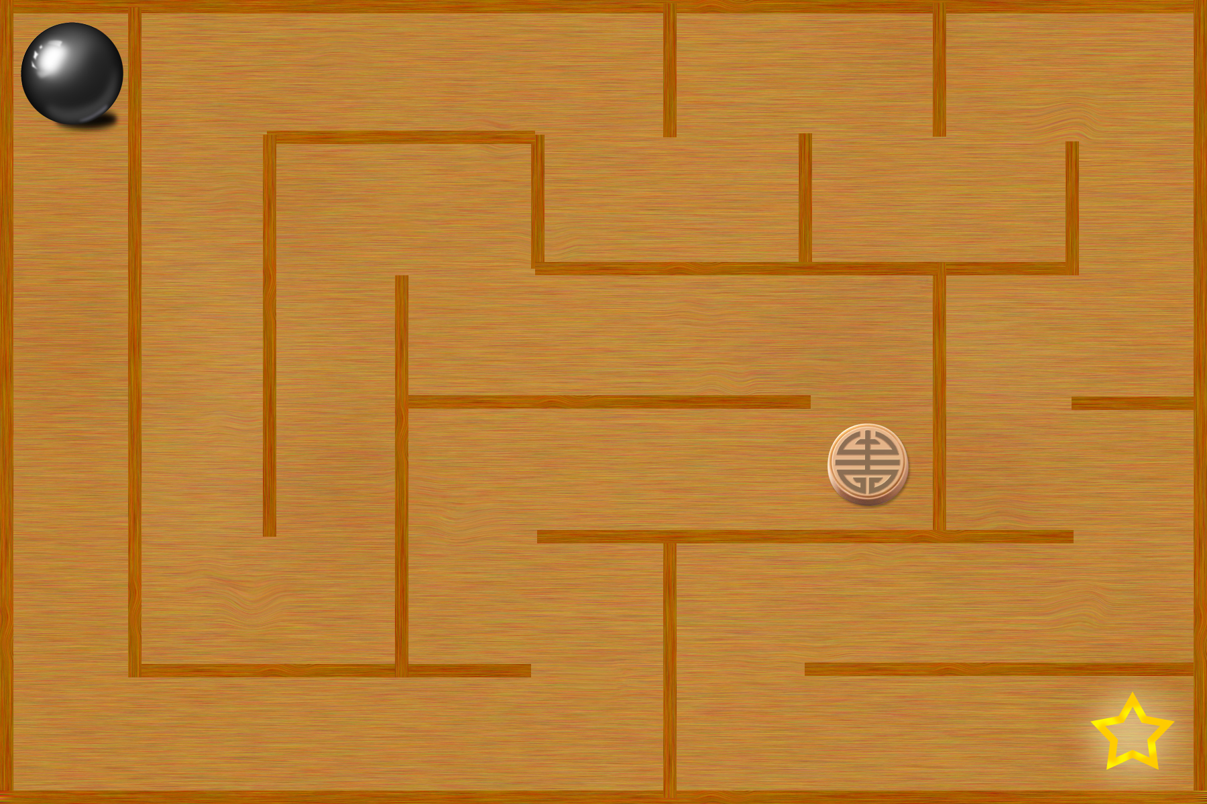

Figure 1. Fully visible



Figure 2. Ball leaves trace



Figure 3. Glowing ball

## Screen Objects and Actions

#A discussion of screen objects and actions associated with those objects#

**Disclaimer and confidentiality**

The information contained in this proposal is strictly confidential and proprietary to Global Software Foundation (“GSF”) and must not be disclosed to any other person by XXXXor by any of its employees without the prior written consent of GSF. Similarly, the information must not be further reproduced and must only be used by XXXXfor the purpose of the development of the application.

XXXXis permitted to disclose the information only to those of its employees and/or professional advisors who need to have access to it and only to the extent required to enable them to carry out the evaluation of the proposal. XXXXwill notify such employees and/or professional advisors of the terms of this understanding and shall procure that such employees and/or professional advisers comply with it. If XXXXXdoes not accept this proposal, all copies of this document must be returned immediately to GSF.

GSF shall have no liability to XXXXbased on or relating to the use by XXXXof any of the information contained in this proposal.

Unless otherwise stated, this document is indivisible and therefore it may only be accepted as a whole.

Global Software Foundation

XXXX

Helsinki

Finland

Telephone:

Copyright in this document is the property of Global Software Foundation.

Appendix

#space for any additional information, NB must be referred to in document text eg See Appendix#